Alex Blair

McKenna Galle

Andrew Hutson

CS 373 Final Project Design

**Pong:**

Our group designed the game of Pong using our Nexys 4 DDR boards. We started with the bouncing box with collisions example from class, and we expanded this example to fit what we desired. Our first goal is to achieve a smaller box so that our game would accurately simulate Pong with a ball. This was easily achieved by adjusting the size of the box in the portion where the box is drawn. We also adjusted the timing so that the smaller box does not try and exist at the upper left and lower right corners of where the bigger box would have been. Next we added paddles to both edges of the screen and limited their height so that they could not encompass the entire side of the screen. After that we focused on mapping the paddles to switches on the board. That way the player can control the paddles by moving either switch 0 or 15. If the switch is up then the paddle moves up, and the opposite is true as well. Next the focus was on implementing proper collision with the paddles and a bouncing mechanic so that the players could volley the ball. This was mostly successful, however we did make it so the ball bounces off of any surface on the side of the screen. Our next goal is to increment the 7seg display with the score of each player. We plan to calculate this in a way where if the ball passes the coordinates of the paddle and bounces off of the wall then the opposite side’s player is given a point. We plan to use only the two 7seg display numbers on each end of the display line.

High Level Hardware Block Design:

# VGA Sync

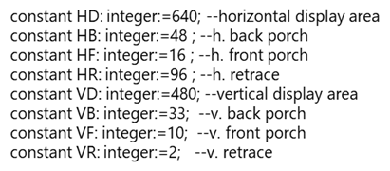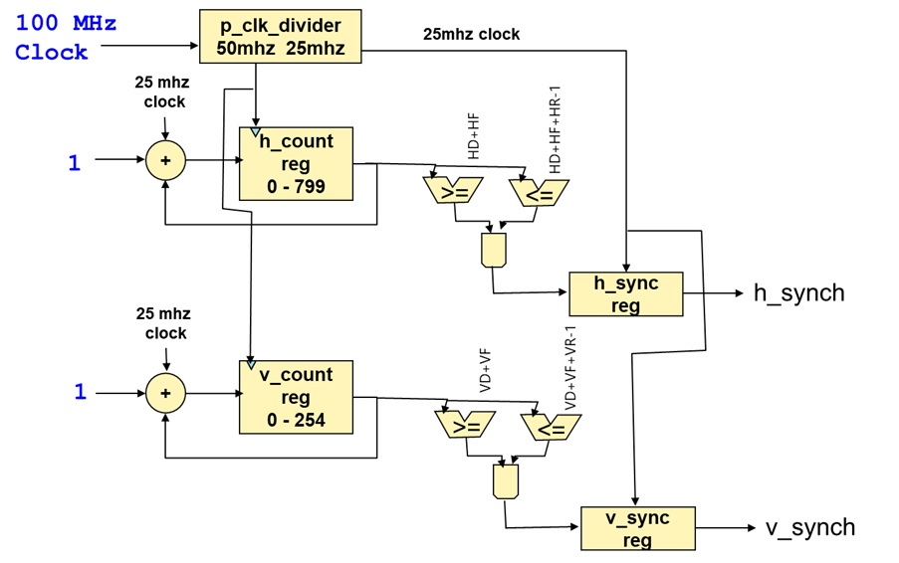

# RGB Generator

